EXPT NO:1 | Implementation of data charts
DATE: 06.01.2026 | Implementation of data charts

PRE-LAB QUESTIONS (PROVIDE BRIEF ANSWERS TO THE FOLLOWING QUESTIONS)

1.How can visualization help an academic institution improve student outcomes?

Visualization helps institutions easily identify trends, patterns, and performance gaps in student data. By visually analyzing marks, attendance, and grades, educators can detect weak subjects, struggling students, and overall progress, enabling timely academic interventions and improved learning outcomes.

2.Which chart types are suitable for comparing subject-wise performance?

Bar charts are most suitable for comparing subject-wise performance because they clearly show differences in average marks across subjects. Column charts and grouped bar charts can also be used when comparing multiple tests or semesters.

3.What type of data scale is used for student marks?

Student marks use a ratio scale because they have a true zero point and allow meaningful comparison of differences and ratios (e.g., a student scoring 80 has twice the marks of a student scoring 40).

4.Why should raw academic data be cleaned before visualization?

Raw academic data may contain missing values, duplicates, or incorrect entries. Cleaning ensures accuracy, consistency, and reliability of the data, preventing misleading visuals and helping generate correct insights from the visualizations.

5.How does visualization support evidence-based decision making?

Visualization converts complex data into easy-to-understand graphical formats, allowing decision-makers to base their actions on factual trends and patterns rather than assumptions. This supports informed decisions related to curriculum improvement, student support, and academic planning.
IN-LAB EXERCISE:
OBJECTIVE:
To design appropriate data charts to analyze and compare academic performance indicators.
SCENARIO:
An autonomous engineering college wants to analyze internal assessment performance of first-year students across five subjects to identify difficult courses and improve teaching strategies.
IN-LAB TASKS (Using R Language)
1.Load required R libraries (ggplot2, dplyr)
Code:
library(ggplot2)
library(dplyr)

2.Import dataset using read.csv()
Code:
data <- read.csv("C:/Users/mohan/Downloads/1.student_performance.csv")
head(data)
str(data)

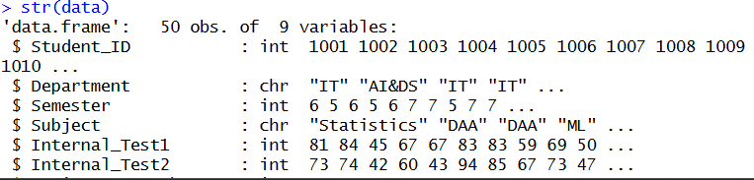

3.Perform basic data preprocessing

Code:
colSums(is.na(data))

data$Subject <- as.factor(data$Subject)
data$Department <- as.factor(data$Department)
data$Semester <- as.factor(data$Semester)
data$Final_Grade <- as.factor(data$Final_Grade)

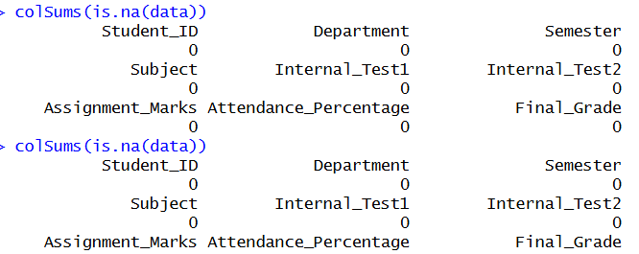

4.Create bar chart for subject-wise average marks
Code:
subject_avg <- data %>%
mutate(Average_Marks = (Internal_Test1 + Internal_Test2) / 2) %>%
group_by(Subject) %>%
summarise(Average_Marks = mean(Average_Marks))

ggplot(subject_avg, aes(x = Subject, y = Average_Marks, fill = Subject)) +
geom_bar(stat = "identity") +
labs(title = "Subject-wise Average Marks",
x = "Subject",
y = "Average Marks") +
theme_minimal()
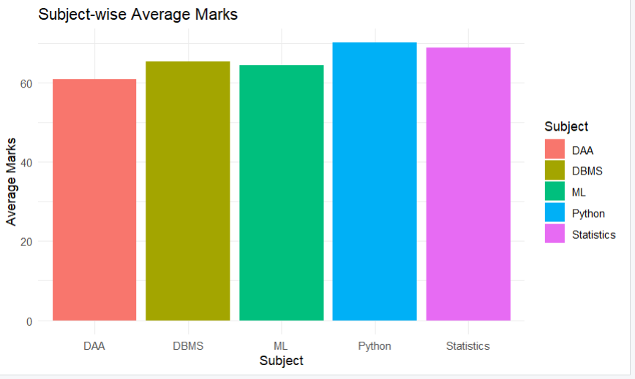

5.Generate line chart for performance trend across tests
Code:
test_trend <- data %>%
summarise(
Test1_Avg = mean(Internal_Test1),
Test2_Avg = mean(Internal_Test2)
)

test_trend_long <- data.frame(
Test = c("Internal Test 1", "Internal Test 2"),
Average_Marks = c(test_trend$Test1_Avg, test_trend$Test2_Avg)
)

ggplot(test_trend_long, aes(x = Test, y = Average_Marks, group = 1)) +
geom_line() +
geom_point() +
labs(title = "Performance Trend Across Internal Tests",
x = "Test",
y = "Average Marks") +
theme_minimal()
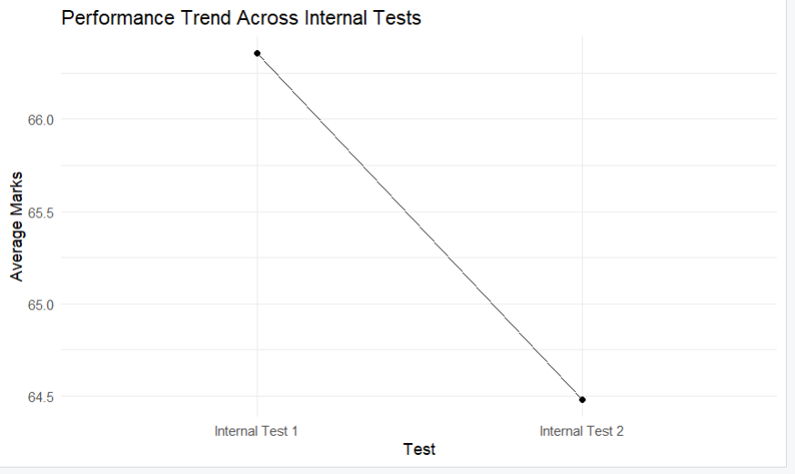

6.Plot pie chart for grade distribution
Code:
grade_dist <- data %>%
count(Final_Grade)

ggplot(grade_dist, aes(x = "", y = n, fill = Final_Grade)) +
geom_bar(stat = "identity", width = 1) +
coord_polar("y") +
labs(title = "Final Grade Distribution") +
theme_void()
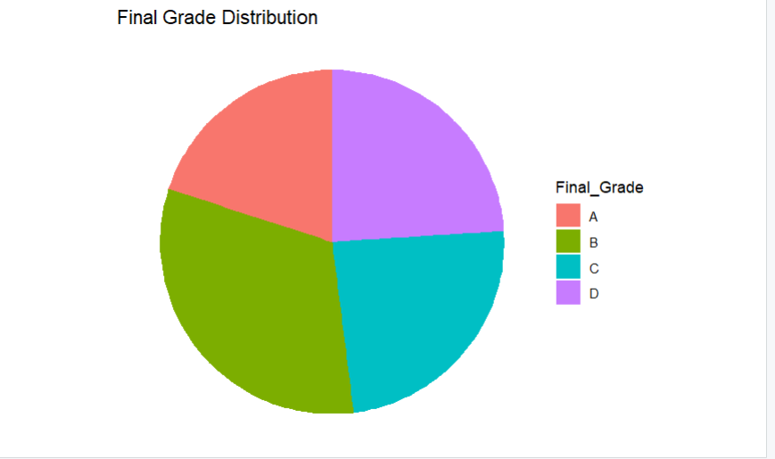

POST-LAB QUESTIONS (PROVIDE BRIEF ANSWERS TO THE FOLLOWING QUESTIONS)
1.Which subject shows consistently low performance and why?

The DAA subject shows consistently low performance. This may be due to the subject’s conceptual difficulty or complex topics. Identifying it allows instructors to provide additional guidance and support to improve student understanding.

2.Why is a line chart suitable for trend analysis?

A line chart effectively displays changes in performance across tests or time. It helps identify upward or downward trends and patterns clearly. This makes it suitable for analyzing academic progress and performance consistency.

3.What limitations does a pie chart have in analytics?

Pie charts are difficult to interpret when there are many categories or small value differences. They do not show precise comparisons or trends effectively. Hence, they are limited for detailed analytical insights.

4.How can this analysis help curriculum planning?

The analysis highlights weak subjects and performance gaps among students. It helps educators modify syllabus content, teaching strategies, and assessment methods. This leads to improved learning outcomes and better curriculum design.

5.How can such visualizations be integrated into AI-driven academic analytics?

These visualizations can be used alongside AI models to identify patterns and predict student performance. AI systems can use this data to recommend personalized learning paths. This supports smarter, data-driven academic decision-making.

ASSESSMENT
Description | Max Marks | Marks Awarded
Pre Lab Exercise | 5
In Lab Exercise | 10
Post Lab Exercise | 5
Viva | 10
Total | 30
Faculty Signature

